**Module 1: Visualization Example from Your Industry**

Find and post one visualization you have seen in your industry (a link to the visualization if it is online is fine). Then describe what the visualization is trying to communicate and the audience of the visualization.

**Introduction:**

The US electricity system and process are often labeled as the world’s main engine. Carbon Brief has plotted the information to show how the US generates electricity. The below data visualization is communicating the shift of electricity production in various ways over the period from 1960 - 2017.

**Audience:** US Energy & Sustainability Plan which affects policies, states, markets, and technologies. It focuses on people’s lives, interests, and future research and developments.

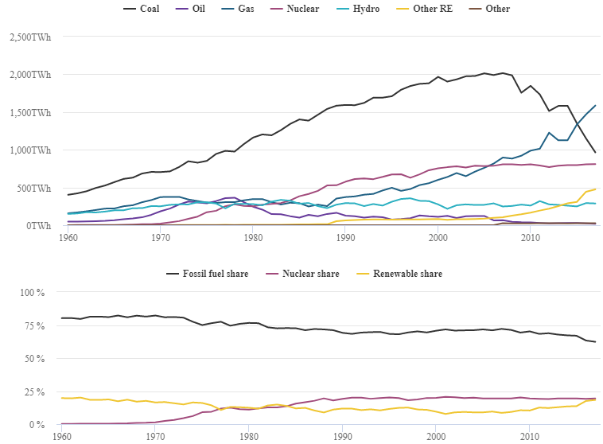

**Key Points:**

* Total electricity was output peaked in 2007 at 4,165 terawatt-hours (TWh), before plunging after the financial catastrophe
* Coal generation peaked in 2007 before tumbling 38% in the last 10 years. It was swapped by gas as the US’s top source of electricity for the 1st time ever in 2016
* Gas has sustained its rise, which initiated well from the early 2000s. Oil-fired generation and production is down two-thirds over the last decade
* Wind and solar have surpassed hydroelectricity generation as the fourth-largest source of electricity in the US
* Nuclear has held stable and still produces somewhat more electricity than all renewable sources shared

**Reference:**

[1] Carbon Brief, Mapped: How the US Generates Electricity was retrieved from <https://www.carbonbrief.org/mapped-how-the-us-generates-electricity>

**Module 2: Ethical Visualizations**

Find both ethical and unethical data visualizations from businesses and organizations and showcase them in a presentation format. You must have one of each. For each example visualization, identify the following:

* Identify whether or not the data visualization is ethical or inappropriate.
* Identify the element(s) that indicates its ethicality and appropriateness, or lack of ethicality and inappropriateness.
* If it is a distorted or inappropriate visualization, explain how to “fix” it or avoid the distortion.
* If it is not a distorted or inappropriate visualization, explain the aspects that make it a good, quality visualization.
* Explain how the data visualization impacts the viewer/audience and the business.

**Ethical:**

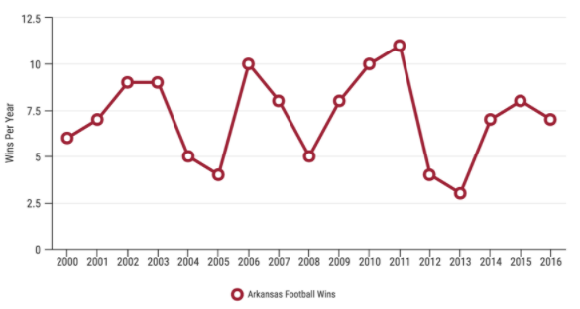

**Properties:**

1. **Ethical:** Yes
2. **Ethicality and Appropriateness of Elements:** Yes
3. **Aspects for Quality Visualization:**

In this example, I looked at Arkansas Razorbacks Football Team win totals over the last 15+ years. The data was plotted on a normal line graph which correlates with the time-series data. The scale is proportionate to the data, showing a greater change over time.

**Unethical:**

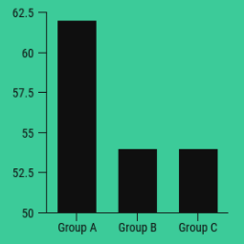

**Properties:**

1. **Ethical:** No
2. **Ethicality and Appropriateness of Elements:** No
3. **Fix it/ Avoid:**

In this example, the baseline is not 0. And, it was skewed by making the baseline to 50. The graph is truncated and misleading. This makes a difference between groups and Group A is looking much larger than Group B and C combined. The graph looks dramatic and not accurate.

**Impact of Visualization on Audience and Business:**

One should follow the Ethical Attributes before manipulating the Y-axis. The vertical axis at 0 offers a more accurate illustration of the data. Cherry-picking creates a false impression of the data and the audience would be deluded. Use the right plot for the right data because they are interrelated. Expanding/ Compressing the scale on a plot can lead to less importance. Maintain the Visual hierarchies and semantics. So, let’s try to avoid these mistakes and make our data story compelling.

**References:**

[1] Ryan McCready (April 2017, 2020) 5 Ways Writers Use Misleading Graphs to Manipulate You, was retrieved from <https://venngage.com/blog/misleading-graphs/>

**Module 3: Ethical and Appropriate Data Visualizations**

After understanding questions, you should ask when evaluating your data, it is also important to remember your audience and the context of your data. Consider your industry or an industry where you would like to work, then based on the module readings, post four additional questions you would ask. Two questions should be designed to elicit the data needs and two should be ones you anticipate being asked given your organization, leaders, colleagues, and business problems. Be sure to give some background on your organization, leaders, colleagues, and business problem.

* Review the following articles for inspiration. Also, be sure to consider this module's content. The Two Questions You Need to Ask Your Data Analysts from Harvard Business Review <https://hbr.org/2015/10/the-two-questions-you-need-to-ask-your-data-analysts>
* Better Questions to Ask Your Data Scientists from Harvard Business Review <https://hbr.org/2016/11/better-questions-to-ask-your-data-scientists%20>

**Company Profile:**

ISF Technologies is a budding start-up founded by a team (including myself as a co-founder) 4 in 2015, India. The main motto of the company is to define the future of real-time aquaculture monitoring systems using smart sensor technology devices and analytics with unique features and captivating market profitable, affordable, and sustainable

**Problems:**

This sector is very much unaddressed and stands behind the scenes due to lack of modern applications, huge investments, unhygienic conditions, old traditional methods, and inaccurate results

**Data needs questions:**

* What parameters/sensor data are required to analyze and monitor the aqua pond in a better way?
* How often the data collected will be utilized for defining the customer needs and what is the market potential that can be targeted?

**Anticipated Questions:**

* Is the product having any competitors in the market? What kind of services and pricing strategies are used?
* What are the plans for customer retention, revenue generation, and customer feedback? Any SWOT analysis employed to fit in the markets?

**References:**

[1] Michael Li (October 27, 2015) The Two Questions You Need to Ask Your Data Analysts was retrieved from <https://hbr.org/2015/10/the-two-questions-you-need-to-ask-your-data-analysts>

[2] Michael Li, Madina Kassengaliyeva, and Raymond Perkins (November 25, 2016) Better Questions to Ask Your Data Scientists was retrieved from <https://hbr.org/2016/11/better-questions-to-ask-your-data-scientists%20>

**Module 4: Storytelling with RShiny**

In your initial post, identify:

* Three issues you had with R (this could be downloading, running code, or other issues)
* Three resources that helped you understand some of the fundamentals
* Three reasons why these resources were helpful

Respond to two classmates with:

* At least one additional resource to help address the issues your classmates addressed in their initial post
* An explanation of why these resources would be helpful

**Issues:**

While working on R I had experienced these errors

* **could not find function:** It occurs when a package hasn’t been loaded into R via library
* **object not found:** It occurs when the R Markdown document refers to an object that has not been defined in an R chunk
* **unmatched parenthesis:** It occurs when the “)” is forgotten to finish a call to a function

**Resources:**

I have gone through these resources and would recommend all my friends to have a look at this to learn and nurture R in a better way

* Asha Hill (May 18, 2018) 9 Useful R Data Visualization Packages for Any Discipline was retrieved from https://mode.com/blog/r-data-visualization-packages/
* An awesome R-shiny list! Was retrieved from https://github.com/grabear/awesome-rshiny
* Exploratory Data Analysis in R by DataCamp was retrieved from https://campus.datacamp.com/courses/exploratory-data-analysis-in-r

**Reasons:**

The above listed resources are available for free and helps us to understand R in a great way

* I have found the concepts of R that are very helpful and interesting as they have brushed up and gave a much clearer idea
* I love this course because it makes us to play around with the code in its interactive IDE
* I have found this informative source on the R Shiny which helps us to make our dashboards appealing

**Module 5: Storytelling with Tableau**

Identify your group and post one or two of your group’s visualizations. Provide a short, one to two sentence summaries of your graph.

**Data Visualization in Tableau:**

Tableau is a Data Visualization tool that is widely used for Business Intelligence, Data Analysis, Dashboarding, and Reporting. It helps create interactive graphs and dynamic charts in the form of dashboards, worksheets, and stories to gain business insights and make strategic decisions.

**Plot 1:**

The 2015 census counted 666,134 street trees citywide, a 12.5% increase from 2005. Queens has the most trees, with 242,414, followed by Brooklyn with 173,063 and Staten Island with 103,313 street trees. The borough with the greatest increase in population since 2005, however, is the Bronx (39%), followed by Manhattan (29%), and then Brooklyn (21%).

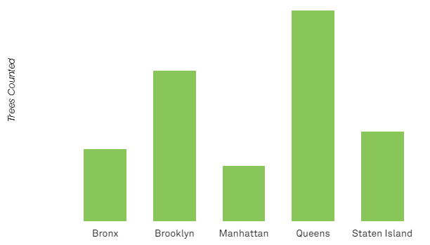

**Plot 2:**

Census data collectors measured the circumference of each street tree, which was then converted to diameter. The charts below show the sizes of trees in each census, in six-inch groupings. These snapshots of the structure of the street tree population from 1995, 2005, and 2015 can also be compared for a better understanding of change over time.

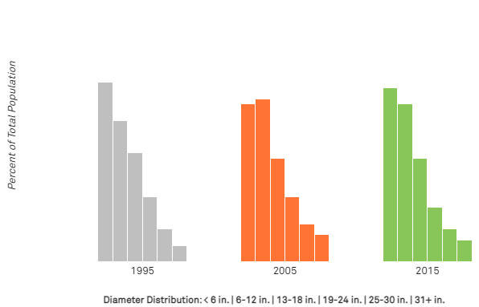

**References:**

[1] Pavleen Kaur (July 27, 2017) Tableau for Beginners – Data Visualization made easy was retrieved from https://www.analyticsvidhya.com/blog/2017/07/data-visualisation-made-easy/

[2] Parul Pandey (Sept 24th, 2018) Data Visualization with Tableau was retrieved from https://www.datacamp.com/community/tutorials/data-visualisation-tableau